|  |  |
| --- | --- |
|  | **English 3**  Semester 2 Credit Recovery Opportunity  Springboard |

**Option 1: Unit 4, Embedded Assessment 2**

**Writing an Analytical Essay**

Assignment:

Write an analytical essay in which you discuss how Zora Neale Hurston’s writing is both a reflection of and a departure from the ideas of the Harlem Renaissance. Include aspects of the Harlem Renaissance that you see reflected in Hurston’s writing as well as characteristics of Hurston’s writing that are departures from selected aspects of the Harlem Renaissance.

Prework: Read Their Eyes Were Watching God in preparation to write this essay.

|  |  |
| --- | --- |
| Planning and Pre-Writing | * What resources on the Harlem Renaissance can you use to help you plan your work? * What writings by Zora Neale Hurston will you refer to? * What elements of the Harlem Renaissance do you recognize in Hurston’s writing, and what elements of her writings seem to be departures from those aspects? |
| Drafting | * How can you state your claim as a single thesis statement so that it captures your thinking? * What organizational pattern will best allow you to compare Hurston’s work to aspects of the Harlem Renaissance? How will you use textual evidence from your sources to support your ideas? How will you use commentary to explain how this evidence relates to your thesis? * Is the evidence that you use cited in a way that will allow your audience to know which source is being used every time? Does your works cited page provide all the information necessary for your audience? |
| Evaluating and Revising | * How can you use transitions so that one idea moves smoothly to the next? * How will you use the Scoring Guide and peer responses to help guide your revision? |
| Checking and Editing for Publication | * How will you ensure that your essay maintains an academic, formal tone; that it seamlessly embeds quotations within the text; and that it uses varied syntax? * How will you check for grammatical and technical accuracy? |

Reflection:

After completing this Embedded Assessment, think about how you went about accomplishing this assignment and respond to the following question:

* How did the use of both primary and secondary sources help you examine how writers’ works can be a product of both their time and their own personal perspective?

Resources:

* This Embedded Assessment is the culmination of Unit 4, Part 2. This portion of the unit begins on Page 576 of the English 3 Student Edition.

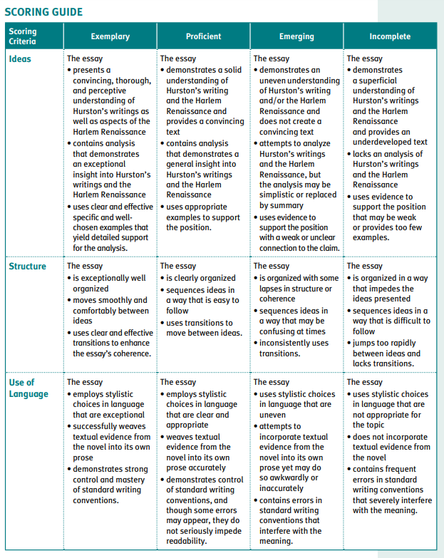

**Option 2: Springboard Writer’s Workshop Research Writing**

Learning targets:

* Engage in steps of the research process to answer a question, and share your findings in a research presentation.
* Gather and synthesize information from multiple sources to answer a research question, and assess the reliability and validity of each source you use.
* Consult a style manual and adhere to guidelines for accurately citing sources.
* Share research findings in a clear and logically structured presentation appropriate to purpose, audience, and task.
* When presenting research findings, demonstrate command of standard English conventions

**Research Writing**

To write reports or communicate information to others, you may need to conduct research on a chosen topic. Creating and following an organized plan for your research will help you collect appropriate information for your finished report or communication. Be sure to:

* Develop a research plan for a research question on a multifaceted topic.
* Locate and synthesize information from multiple sources that identifies the issues and debates in the field of inquiry.
* Include graphics, visuals, images, and other forms to represent information.
* Conduct an investigation of sources using tools that demonstrate the reliability, validity, authority, objectivity, and usefulness of sources.
* Incorporate summarized and/or quoted material from research, correctly cited and integrated into the text, as evidence to support conclusions and reasoning.
* Create a presentation of findings to address a specific purpose and audience.
* Use written text that avoids wordiness and redundancies.

Activity 1: Discovering the Elements of Research Writing

Research a Topic

1. Think about your previous experiences with research. Work with a partner to record and share responses.
   1. How did you choose a topic to research?
   2. What role did audience and purpose play in helping you choose a topic?
   3. How did you find sources to research your topic?
   4. What types of sources did you use?
   5. How did you decide which sources were good (i.e., valid, reliable, objective, authoritative)?
   6. How did you take notes and summarize the information you found?
   7. How did you write about or present your findings?

As You Read

* What is the research question? Record your response in the margin.
* Circle the thesis sentence.
* Take notes on the possible opposing arguments to the writer’s point of view.
* Look at the sources cited for the information presented. How do you know the sources are credible and reliable? Which are primary and which are secondary sources? Which is a print source and which is electronic?

Working from the Text

**Language and Writer’s Craft Practice: Avoiding Wordiness and Redundancy**

Often, students find themselves aiming for the lengthiest sentence possible, especially when there is a required length to reach. However, audiences appreciate when language is precise and concise. This is especially true when presenting research, as often the audience for a research presentation has a preconceived time limit in mind.

**Wordiness** is when more words than necessary are used to make a point.

*The Great Depression was a very serious crisis and it affected lots and lots of people.*

By definition, a crisis is “very serious.” In addition, the sentence can be tightened up by revising it to the new version below:

*The Great Depression was a crisis that affected many people.*

**Redundancy** is when a sentence makes the same point more than once.

For some, acne is a preventable problem that can be avoided with careful hygiene.

Here, the writer states that acne is “preventable,” then goes on to state that it “can be avoided.” Both of these phrases provide the same information. The sentence below conveys just as much information:

*For some, acne can be avoided with careful hygiene.*

**Practice**

*Look over the sentences below, and revise them to avoid wordiness and redundancy.*

*The school was closed all day on account of the giant blizzard of snow that went from the morning until late at night.*

*Thomas Edison was an amazing inventor who created hundreds of new devices and technology.*

*The committee meets one time every month and looks over the way we spend our finances and oversees our use of resources.*

*It is very probable that the classes will be on Monday evenings and Wednesday evenings.*

As you continue to work through the process of writing research presentations, you will be expected to revise overly wordy or redundant text so that your work is clear and to the point.

*For the purpose of this assignment, we are skipping activities 2 and 3 which require group/class writing.

Activity 4: Independent Writing

Research a topic, and present your findings in an essay.

Be sure to:

* Choose an issue that has multiple competing perspectives and can be researched.
* Write a major research question.
* Create a research plan, identifying valid sources and generating search terms to use.
* Determine an appropriate audience that would need the information from your research. Consider what kind of background information they might need on the topic. Address this audience directly in your presentation.
* Conduct the research and take notes.
* Evaluate your findings, and decide whether to write additional research questions.
* Compile your findings. Use a variety of sources.
* Based on your thesis statement, develop an organizational structure for presenting your evidence, reasoning, and conclusions.
* Refer to the Scoring Guide for this writing task—it will help you plan your efforts.
* Write a thesis paragraph and paragraphs that support your thesis.
* Revise the text to avoid wordiness and redundancies.

Resources:

The full activities are found within the English 3 Writers Workshop Student Edition. Pages 65-72.

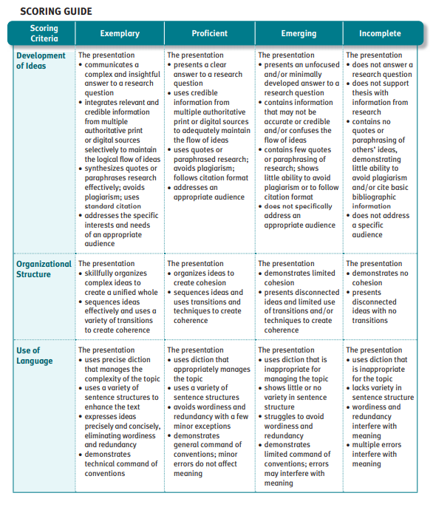

*Please note, where the rubric says “presentation” it means essay.